**17th March 2016**

**YOKOHAMA hits the trail as a sponsor of Easter Jeep Safari Week’s 50th anniversary**

The tyre maker joins the celebration, sponsoring the Day Canyon Point Trail and launching a new pick-up/SUV tyre, the GEOLANDAR A/T G015

SANTA ANA, CA – Yokohama Tire Corporation (YTC) and thousands of off-road driving enthusiasts are prepping for the 50th anniversary of Easter Jeep Safari Week, 19th – 27th March in Moab, Utah. Approximately 25,000 to 35,000 visitors are expected to attend and participate in the event. Many will also drive the trails where YTC will be part of the festivities, sponsoring the Day Canyon Point Trail in conjunction with the launch of its new GEOLANDAR A/T G015 pick-up/SUV tyre, which officially goes on sale 1st April in the US.

YTC is the official 2016 sponsor for the 70-mile-long Day Canyon Point Trail on 21st March, which features sweeping vistas, several shelf ledges, varied terrain and the notorious obstacle Broken Bill Hill. The challenging trail offers views of the Colorado River, Moab Rim and rock formations like the Puppet Show and the Lodges.

“YOKOHAMA is known for producing some of the most innovative tyres on the market, and I cannot think of a better way to showcase the GEOLANDAR A/T G015 than in Moab,” said Alan Holtschneider, YTC director of marketing.

According to the Red Rock 4-Wheelers (RR4W), the longstanding organization that runs Easter Jeep Safari Week, sponsoring a trail helps support initiatives that benefit the off-roading community.

Yokohama Tire Corporation is the North American manufacturing and marketing arm of Tokyo, Japan-based The Yokohama Rubber Co., Ltd., a global manufacturing and sales company of premium tyres since 1917. Servicing an extensive sales network throughout the U.S., Yokohama Tire Corporation is a leader in technology and innovation. The Company’s complete product line includes tyres for high-performance, light truck, passenger car, commercial truck and bus, and off-the-road mining and construction applications.

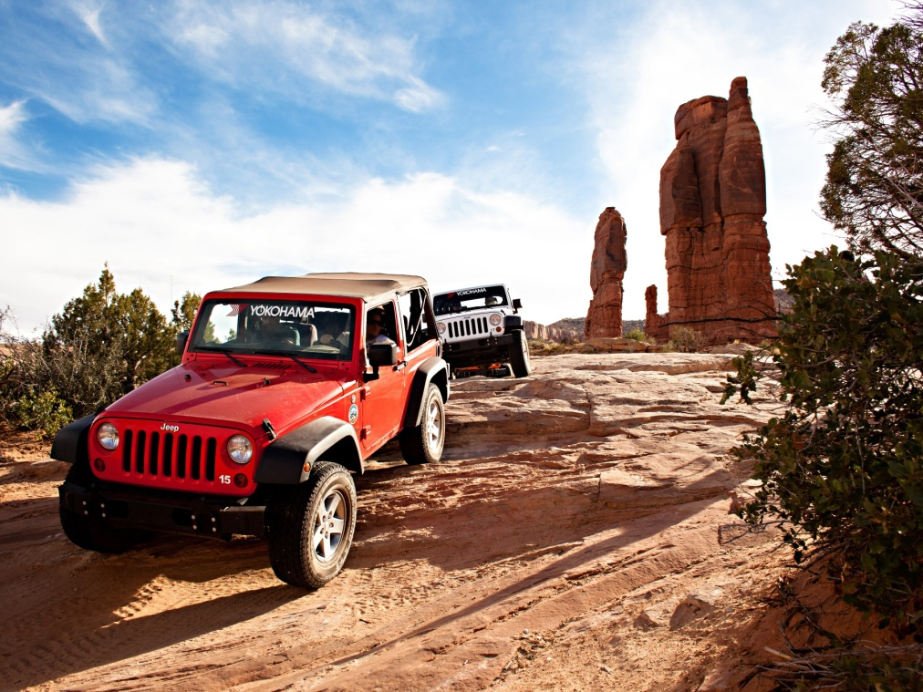

*YOKOHAMA a sponsor of Easter Jeep Safari Week*